Vinitha V_Wipro Training(3)_Satinnder

NAME : Vinitha V

EMAIL_ID : [vinikavisvg@gmail.com](mailto:vinikavisvg@gmail.com)

DAY 1 – 14/06/2024

TASK 1 :

# Compare Dual Core VS Quad Core.

|  |  |
| --- | --- |
| DUAL CORE | QUAD CORE |
| A Dual-core processor has two cores | Quad-core processor has four Cores |
| Dual-core consumes less power. | Quad-core consumes more power. |
| Dual-core is lighter and no heat is generated when working. | Quad-core processors generates heat which can heat up the device. |
| Dual core lacks in Graphics. | Quad-core is better equipped to handle high quality graphics. |
| Dual-core is less powerful in terms of speed. | Quad-core processors are faster than dual-core processors. |
| Dual-core does not support Multi-tasking like quad-core. | Quad-core processors offer improved performance, better multitasking capabilities, and efficiency over  single-core and dual-core processors. |

TASK 2:

# Compare Intel i family (i5 and i7).

|  |  |  |
| --- | --- | --- |
|  | INTEL i FAMILY(i5) | INTEL i FAMILY(i7) |
| Core Count and Threads | Typically, i5 processors are equipped with four to six cores and lack hyper-threading, resulting in four to six threads. | i7 processors usually boast six to eight cores and support  hyper-threading, effectively doubling the number of threads  (twelve to sixteen threads). |
| Clock Speeds | i5 processors tend to have slightly lower base and boost  clock speeds compared to i7 processors. | i7 processors generally feature higher base and  boost clock speeds, providing faster performance especially  in demanding applications. |
| Cache Size | i5 processors typically come with a smaller cache size  compared to i7 processors, impacting the speed of data access. | i7 processors usually have a larger cache size,  allowing for quicker data retrieval and improved overall performance. |
| Price | i5 processors are more budget-friendly compared to  i7 processors, making them an attractive option for users  seeking a balance of performance and affordability. | i7 processors come at a higher price point due to  their increased performance capabilities and additional features. |
| Usage and Applications | i5 processors are well-suited for mainstream users,  light gamers, and those engaged in moderate multitasking  and content creation. | i7 processors are designed for power users and  professionals involved in resource-intensive tasks like  video editing, 3D modeling and heavy multitasking. |

DAY 2 – 17/06/2024

TASK 1 :

# Binary To Decimal Conversion

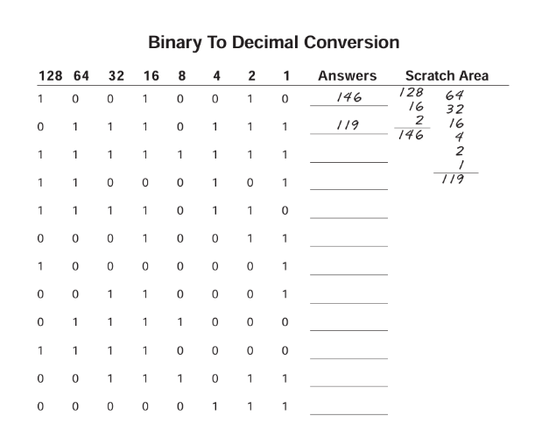

Answer :

|  |  |  |  |  |  |  |  |  |
| --- | --- | --- | --- | --- | --- | --- | --- | --- |
| 128 | 64 | 32 | 16 | 8 | 4 | 2 | 1 | Answers |
| 1 | 0 | 0 | 1 | 0 | 0 | 1 | 0 | 146 |
| 0 | 1 | 1 | 1 | 0 | 1 | 1 | 1 | 119 |
| 1 | 1 | 1 | 1 | 1 | 1 | 1 | 1 | 255 |
| 1 | 1 | 0 | 0 | 0 | 1 | 0 | 1 | 197 |
| 1 | 1 | 1 | 1 | 0 | 1 | 1 | 0 | 246 |
| 0 | 0 | 0 | 1 | 0 | 0 | 1 | 1 | 19 |
| 1 | 0 | 0 | 0 | 0 | 0 | 0 | 1 | 129 |
| 0 | 0 | 1 | 1 | 0 | 0 | 0 | 1 | 49 |
| 0 | 1 | 1 | 1 | 1 | 0 | 0 | 0 | 120 |
| 1 | 1 | 1 | 1 | 0 | 0 | 0 | 0 | 240 |
| 0 | 0 | 1 | 1 | 1 | 0 | 1 | 1 | 59 |
| 0 | 0 | 0 | 0 | 0 | 1 | 1 | 1 | 7 |

TASK 2 :

# Decimal To Binary Conversion

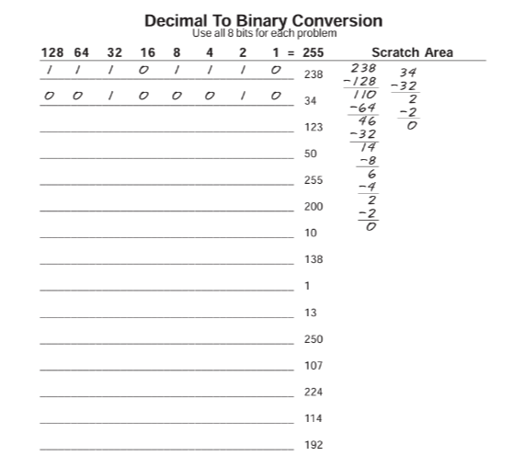

Answer :

|  |  |  |  |  |  |  |  |  |
| --- | --- | --- | --- | --- | --- | --- | --- | --- |
| 128 | 64 | 32 | 16 | 8 | 4 | 2 | 1 | 255 |
| 1 | 1 | 1 | 0 | 1 | 1 | 1 | 0 | 238 |
| 0 | 0 | 1 | 0 | 0 | 0 | 1 | 0 | 34 |
| 0 | 1 | 1 | 1 | 1 | 0 | 1 | 1 | 123 |
| 0 | 0 | 1 | 1 | 0 | 0 | 1 | 0 | 50 |
| 1 | 1 | 1 | 1 | 1 | 1 | 1 | 1 | 255 |
| 1 | 1 | 0 | 0 | 1 | 0 | 0 | 0 | 200 |
| 0 | 0 | 0 | 0 | 1 | 0 | 1 | 0 | 10 |
| 1 | 0 | 0 | 0 | 1 | 0 | 1 | 0 | 138 |
| 0 | 0 | 0 | 0 | 0 | 0 | 0 | 1 | 1 |
| 0 | 0 | 0 | 0 | 1 | 1 | 0 | 1 | 13 |
| 1 | 1 | 1 | 1 | 1 | 0 | 1 | 0 | 250 |
| 0 | 1 | 1 | 0 | 1 | 0 | 1 | 1 | 107 |
| 1 | 1 | 1 | 0 | 0 | 0 | 0 | 0 | 224 |
| 0 | 1 | 1 | 1 | 0 | 0 | 1 | 0 | 114 |
| 1 | 1 | 0 | 0 | 0 | 0 | 0 | 0 | 192 |

TASK 3 :

# Address Class Identification

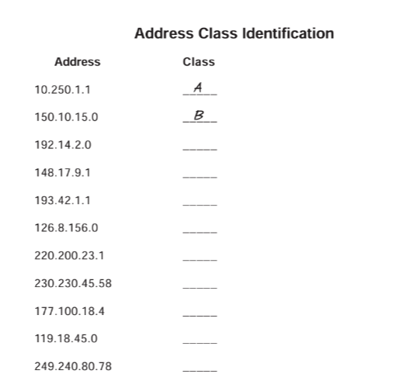

Answer :

|  |  |
| --- | --- |
| Address | Class |
| 10.250.1.1 | A |
| 150.10.15.0 | B |
| 192.14.2.0 | C |
| 148.17.9.1 | B |
| 193.42.1.1 | C |
| 126.8.156.0 | A |
| 220.200.23.1 | C |
| 230.230.45.58 | D |
| 177.100.18.4 | B |
| 119.18.45.0 | A |
| 249.240.80.78 | E |

TASK 4 :

# Network & Host Identification

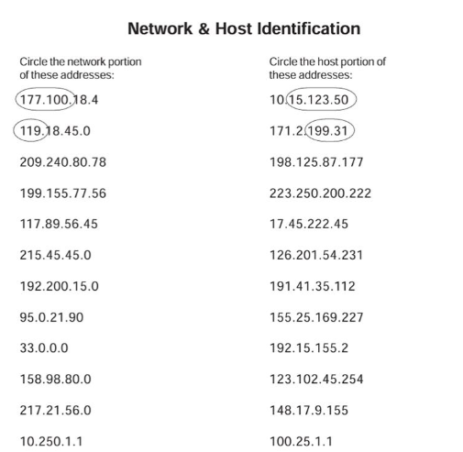

Answer :

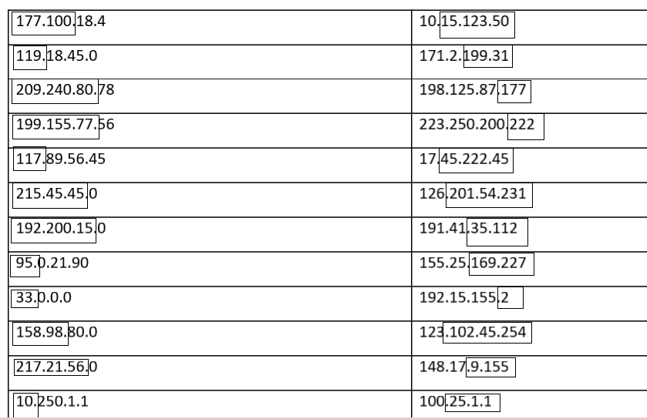

TASK 5 :

# Network Addresses

## Using the IP address and subnet mask shown write out the network address :

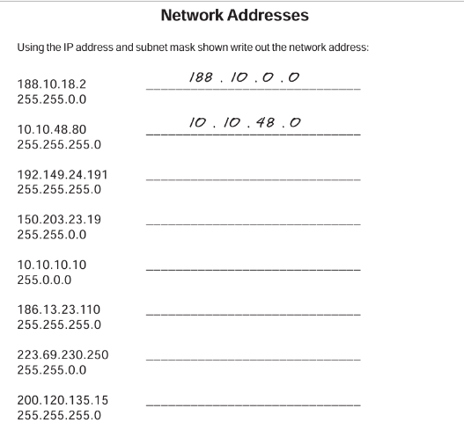

Answer :

|  |  |
| --- | --- |
| 188.10.18.2  255.255.0.0 | 188.10.0.0 |
| 10.10.48.80  255.255.255.0 | 10.10.48.0 |
| 192.149.24.191  255.255.255.0 | 192.149.24.0 |
| 150.203.23.19  255.255.0.0 | 150.203.0.0 |
| 10.10.10.10  255.0.0.0 | 10.0.0.0 |
| 186.13.23.110  255.255.255.0 | 186.13.23.0 |
| 223.69.230.250  255.255.0.0 | 223.69.0.0 |
| 200.120.135.15  255.255.255.0 | 200.120.135.0 |

TASK 6 :

# Host Addresses

## Using the IP address and subnet mask shown write out the host address :

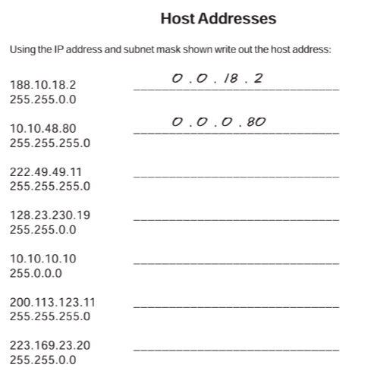

Answer :

|  |  |
| --- | --- |
| 188.10.18.2  255.255.0.0 | 0.0.18.2 |
| 10.10.48.80  255.255.255.0 | 0.0.0.80 |
| 222.49.49.11  255.255.255.0 | 0.0.0.11 |
| 128.23.230.19  255.255.0.0 | 0.0.230.19 |
| 10.10.10.10  255.0.0.0 | 0.10.10.10 |
| 200.113.123.11  255.255.255.0 | 0.0.0.11 |
| 223.169.23.20  255.255.0.0 | 0.0.23.20 |

TASK 7:

# Default Subnet Masks

## Write the correct default subnet mask for each of the following addresses:

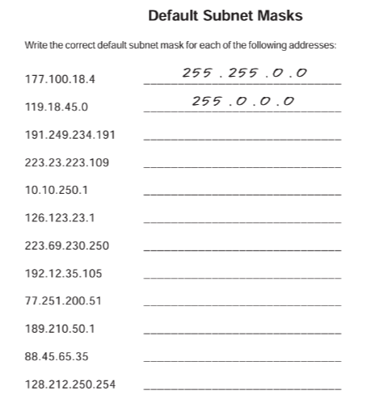

Answer :

|  |  |
| --- | --- |
| 177.100.18.4 | 255.255.0.0 |
| 119.18.45.0 | 255.0.0.0 |
| 191.249.234.191 | 255.255.0.0 |
| 223.23.223.109 | 255.255.255.0 |
| 10.10.250.1 | 255.0.0.0 |
| 126.123.23.1 | 255.0.0.0 |
| 223.69.230.250 | 255.255.225.0 |
| 192.12.35.105 | 255.255.225.0 |
| 77.251.200.51 | 255.0.0.0 |
| 189.210.50.1 | 255.255.0.0 |
| 88.45.65.35 | 255.0.0.0 |
| 128.212.250.254 | 255.255.0.0 |

DAY 3 – 18/06/2024

TASK 1 :

1. Connect two routers
2. Connect Router with a Switch
3. Connect Router with PC
4. Connect PC with a switch

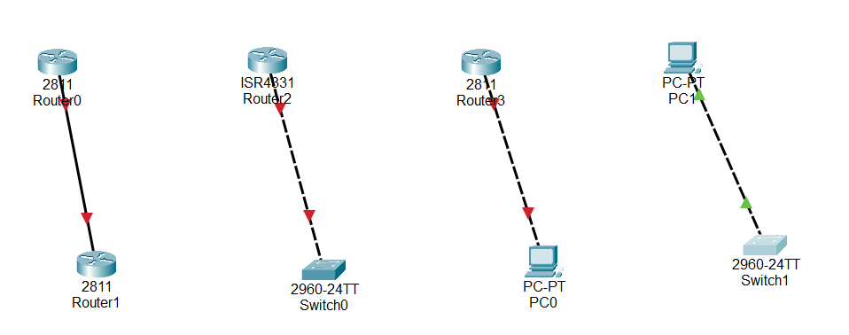

TASK 2 :

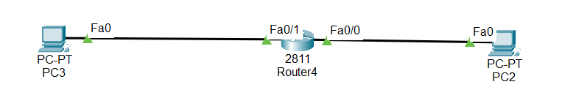

PC2

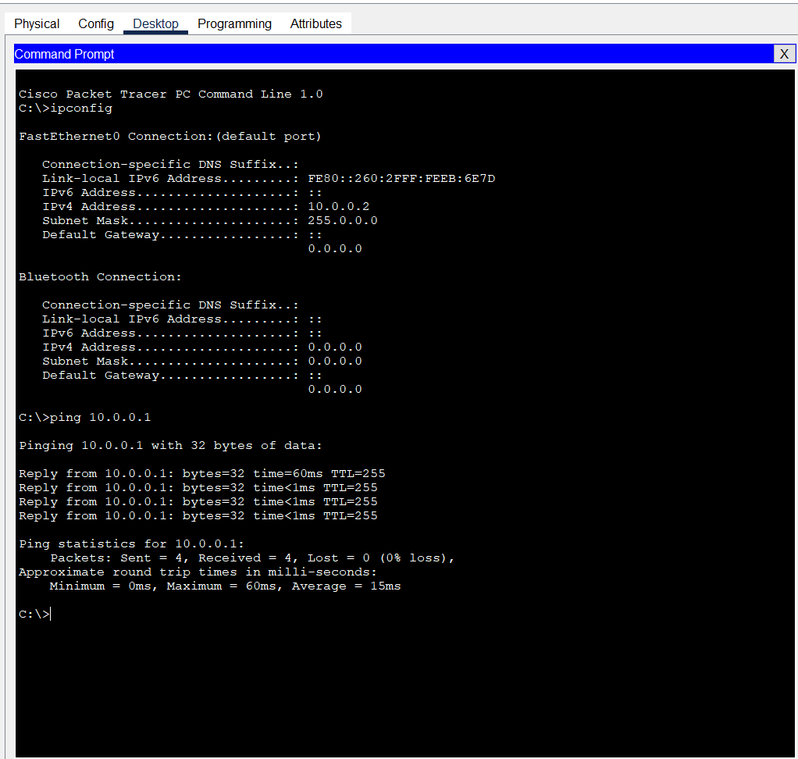

PC3

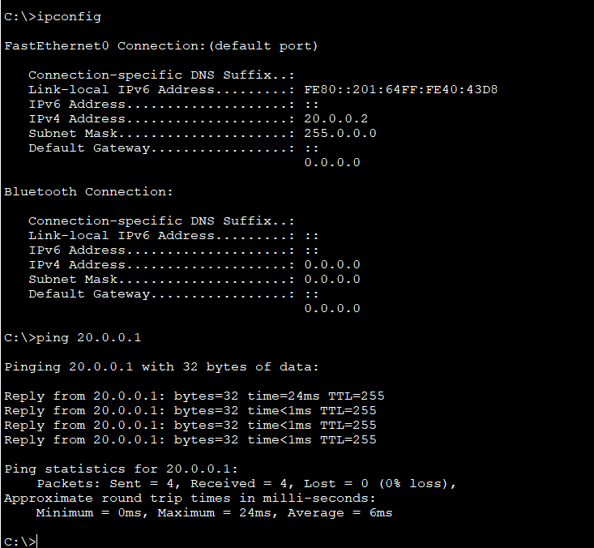

TASK 3 :

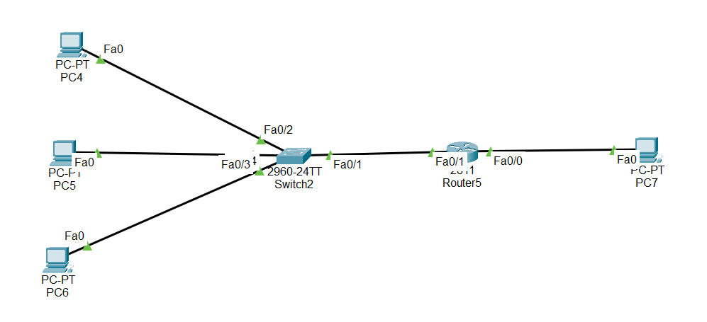

PC4

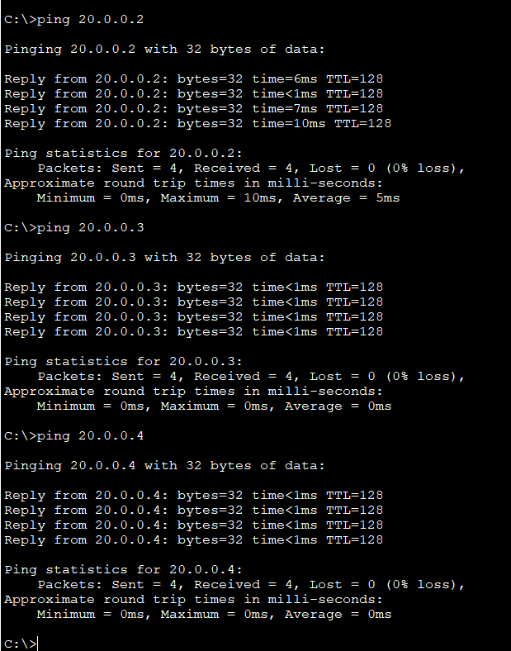

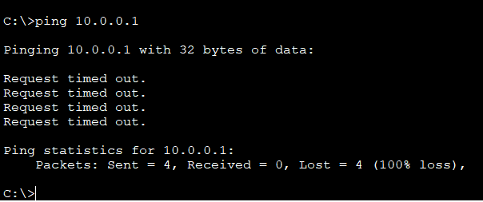

PC7

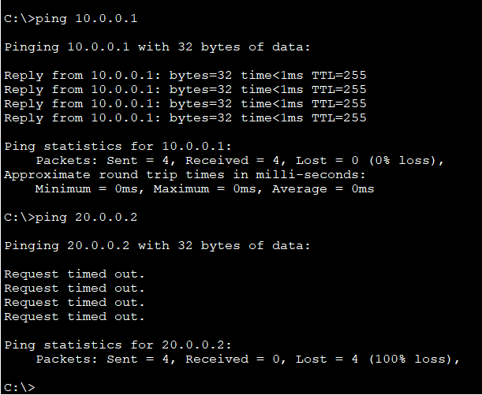

TASK 4 :

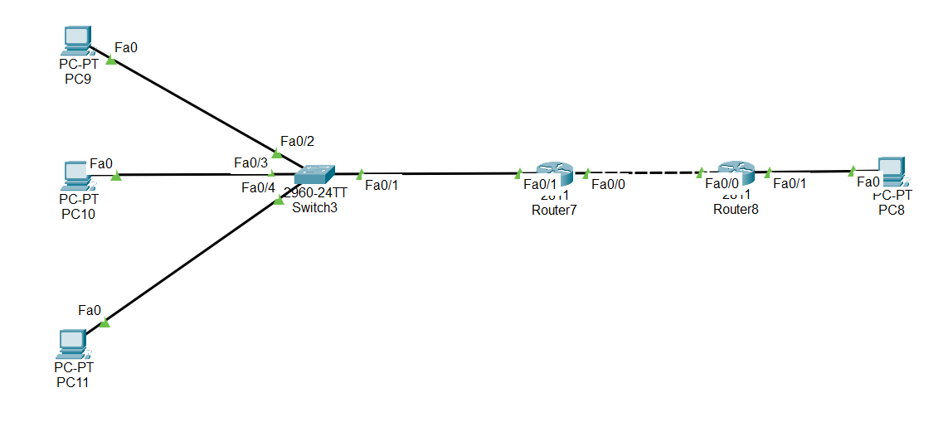

PC9

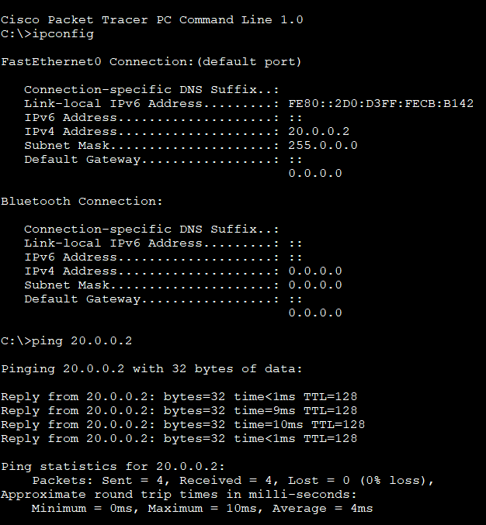

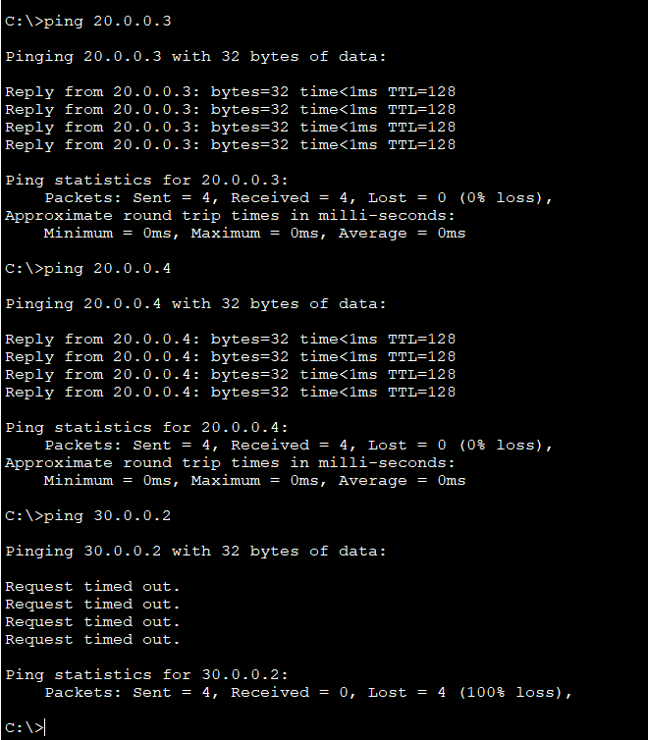

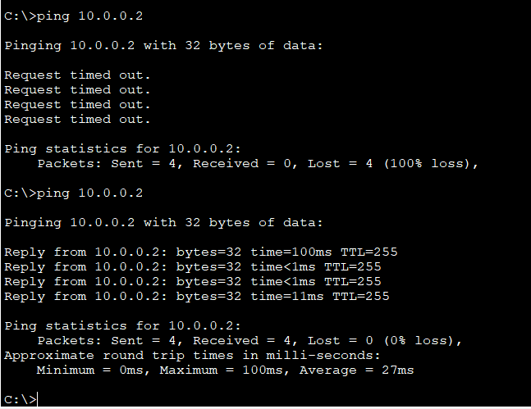

PC8

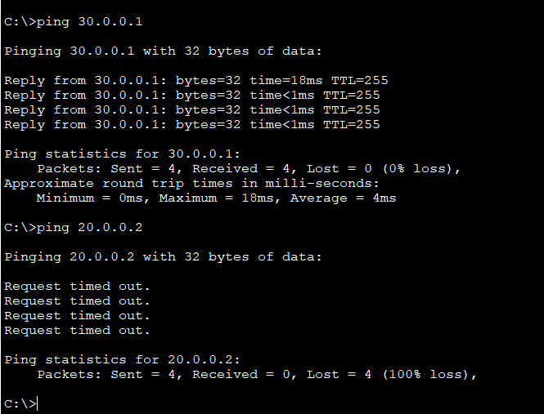

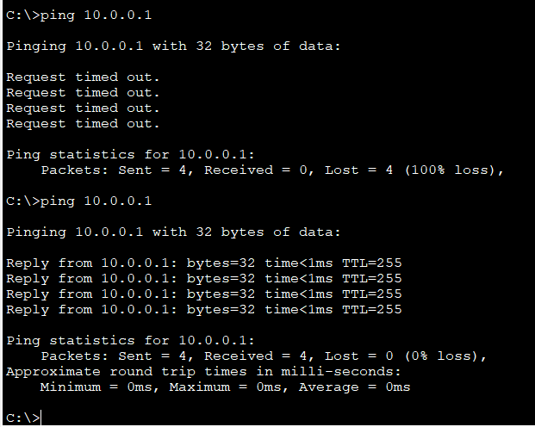

|  |  |  |  |  |
| --- | --- | --- | --- | --- |
| Connection | R7 F0/0 | R7 F0/1 | R8 F0/0 | R8 F0/1 |
| PC9 | Connected | Connected | Not Connected | Not Connected |
| PC8 | Not Connected | Not Connected | Connected | Connected |

DAY 4 – 19/06/2024

TASK 1 :

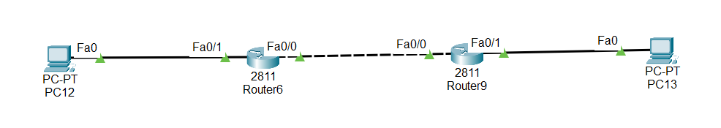

PC12

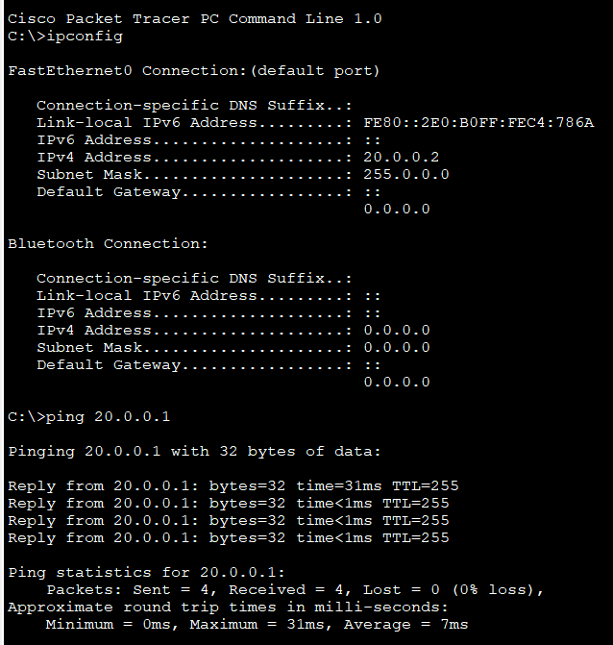

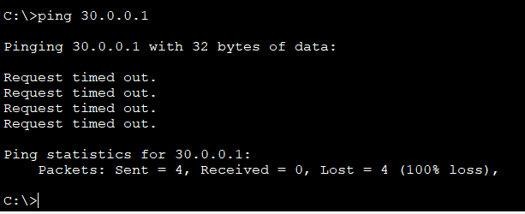

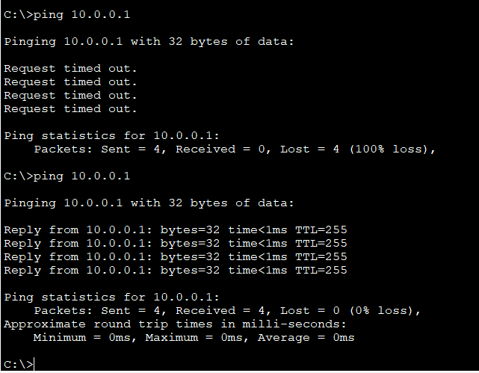

PC13

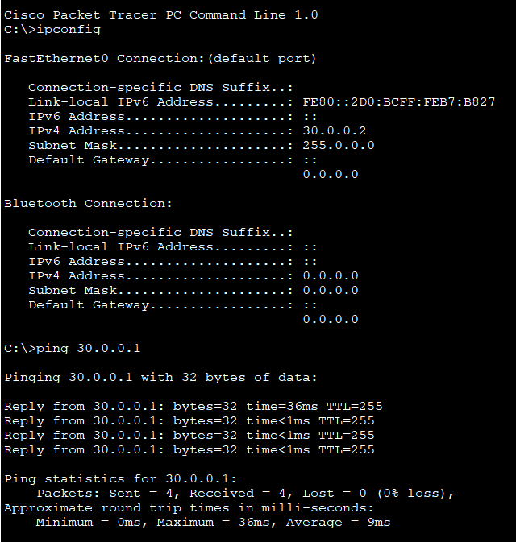

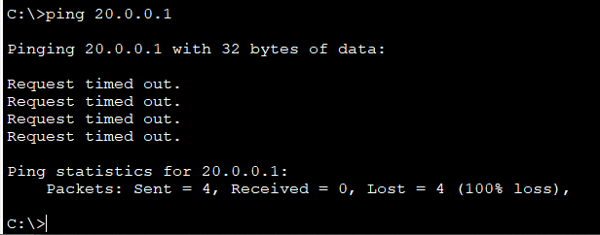

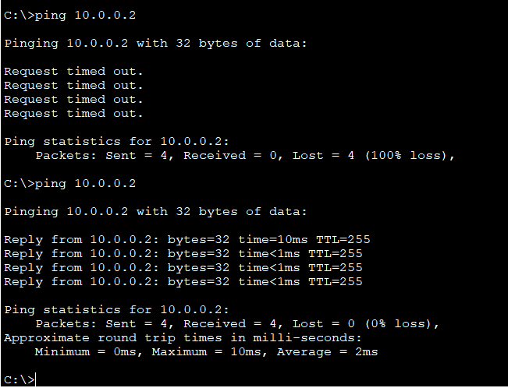

|  |  |  |  |  |
| --- | --- | --- | --- | --- |
| Connection | R6 F0/0 | R6 F0/1 | R9 F0/0 | R9 F0/1 |
| PC12 | Connected | Connected | Not Connected | Not Connected |
| PC13 | Not Connected | Not Connected | Connected | Connected |

TASK 2 :

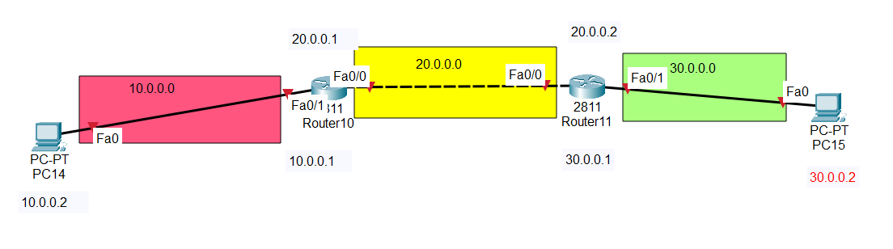

Answer :

Router 10 :

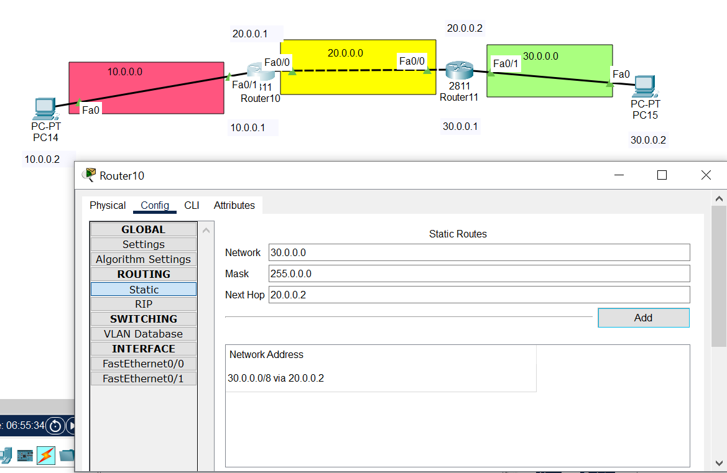

Router 11:

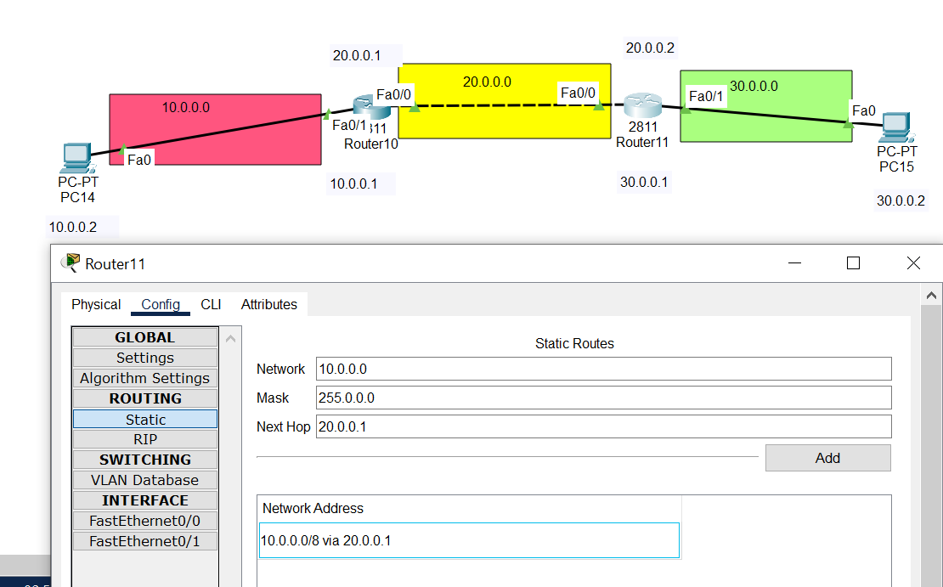

PC14

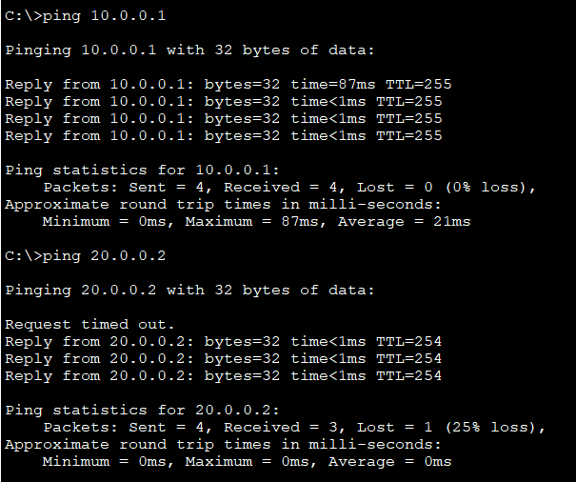

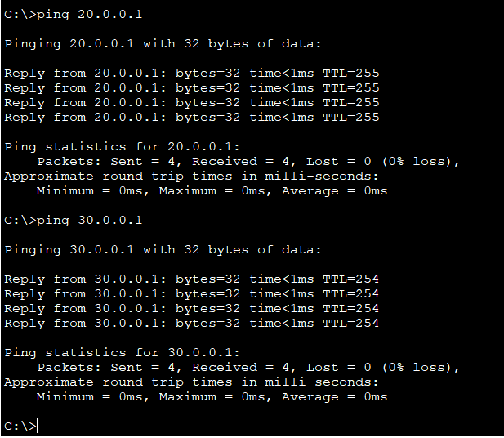

PC15

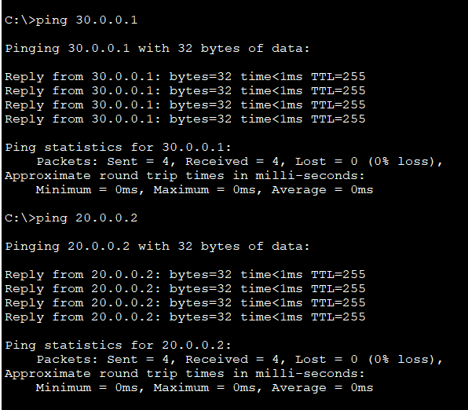

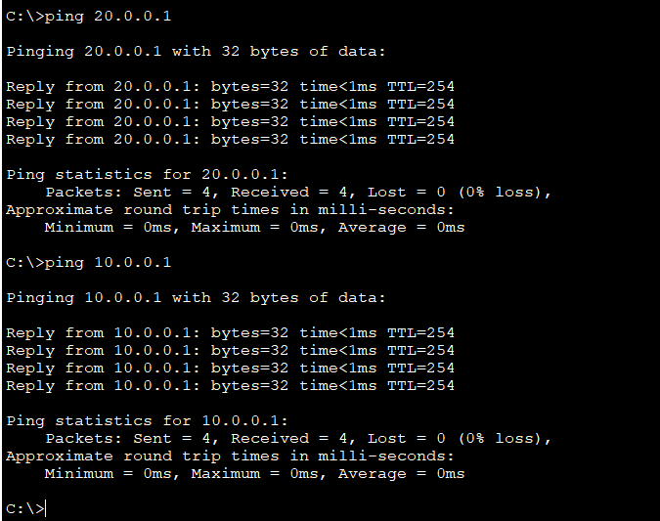

DAY 5 – 20/06/2024

TASK 1 :

# Compare OSI vs TCP/IP

|  |  |  |
| --- | --- | --- |
|  | OSI | TCP/IP |
|  | [OSI](https://www.geeksforgeeks.org/layers-of-osi-model/)stands for Open Systems Interconnection. | [TCP/IP](https://www.geeksforgeeks.org/tcp-ip-model/) stands for Transmission Control Protocol/Internet Protocol. |
|  | It has 7 layers Physical layer, Data Link layer, Network layer, Transport layer, Session layer, Presentation layer, and Application layer. | It has 4 layers named as Physical layer, Network layer, Transport layer, and Application layer. |
|  | Each layer performs its task independently. It was developed in 1984 by the International Organization for Standardization (ISO). | It also can be used as a communications protocol in a private computer network. It was designed by Vint Cerf and Bob Kahn in the 1970s. |
|  |  |  |
| **Advantages** | * Both connection-oriented services and connectionless services are supported. * It is quite flexible. * All the layers work independently. | * Many Routing protocols are supported. * It is highly scalable and uses a client-server architecture. * It is lightweight. |
| **Disadvantages** | * Setting up a model is a challenging task. * Sometimes, it becomes difficult to fit a new protocol into this model. * It is only used as a reference model. | * Little difficult to set up. * Delivery of packets is not guaranteed by the transport layer. * Vulnerable to a synchronization attack. |

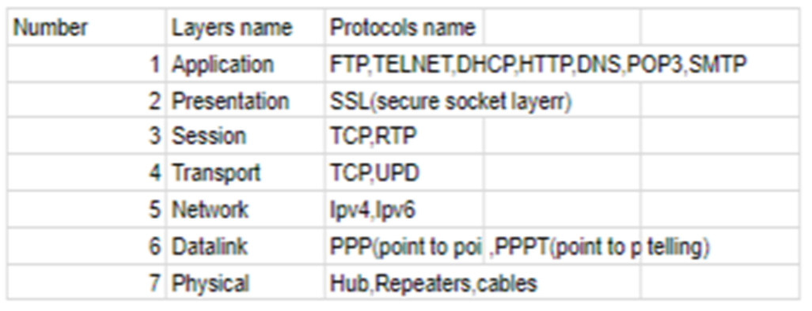

TASK 2 :

# Layer 7 services and their port numbers

The Application Layer is topmost layer in the Open System Interconnection (OSI) model. This layer provides several ways for manipulating the data (information) which actually enables any type of user to access network with ease.

This layer also makes a request to its bottom layer, which is presentation layer for receiving various types of information from it. The Application Layer interface directly interacts with application and provides common web application services. This layer is basically highest level of open system, which provides services directly for application process.

**Functions of Application Layer :**  
 The Application Layer, as discussed above, being topmost layer in OSI model, performs several kinds of functions which are requirement in any kind of application or communication process.

Following are list of functions which are performed by Application Layer of OSI Model –

Data from User <=> Application layer <=> Data from Presentation Layer

* Application Layer provides a facility by which users can forward several emails and it also provides a storage facility.
* This layer allows users to access, retrieve and manage files in a remote computer.
* It allows users to log on as a remote host.
* This layer provides access to global information about various services.
* This layer provides services which include: e-mail, transferring files, distributing results to the user, directory services, network resources and so on.
* It provides protocols that allow software to send and receive information and present meaningful data to users.
* It handles issues such as network transparency, resource allocation and so on.
* This layer serves as a window for users and application processes to access network services.
* Application Layer is basically not a function, but it performs application layer functions.
* The application layer is actually an abstraction layer that specifies the shared protocols and interface methods used by hosts in a communication network.
* Application Layer helps us to identify communication partners, and synchronizing communication.
* This layer allows users to interact with other software applications.
* In this layer, data is in visual form, which makes users truly understand data rather than remembering or visualize the data in the binary format (0’s or 1’s).
* This application layer basically interacts with Operating System (OS) and thus further preserves the data in a suitable manner.
* This layer also receives and preserves data from it’s previous layer, which is Presentation Layer (which carries in itself the syntax and semantics of the information transmitted).
* The protocols which are used in this application layer depend upon what information users wish to send or receive.
* This application layer, in general, performs host initialization followed by remote login to hosts.

**Working of Application Layer in the OSI model :**  
 In the OSI model, this application layer is narrower in scope.   
The application layer in the OSI model generally acts only like the interface which is responsible for communicating with host-based and user-facing applications. This is in contrast with TCP/IP protocol, wherein the layers below the application layer, which is Session Layer and Presentation layer, are clubbed together and form a simple single layer which is responsible for performing the functions, which includes controlling the dialogues between computers, establishing as well as maintaining as well as ending a particular session, providing data compression and data encryption and so on.

At first, client sends a command to server and when server receives that command, it allocates port number to client. Thereafter, the client sends an initiation connection request to server and when server receives request, it gives acknowledgement (ACK) to client through client has successfully established a connection with the server and, therefore, now client has access to server through which it may either ask server to send any types of files or other documents or it may upload some files or documents on server itself.

**Features provided by Application Layer Protocols :**  
 To ensure smooth communication, application layer protocols are implemented the same on source host and destination host.

The following are some of the features which are provided by Application layer protocols-

* The Application Layer protocol defines process for both parties which are involved in communication.
* These protocols define the type of message being sent or received from any side (either source host or destination host).
* These protocols also define basic syntax of the message being forwarded or retrieved.
* These protocols define the way to send a message and the expected response.
* These protocols also define interaction with the next level.

[**Application Layer Protocols:**](https://www.geeksforgeeks.org/protocols-application-layer/)

The application layer provides several protocols which allow any software to easily send and receive information and present meaningful data to its users.

The following are some of the protocols which are provided by the application layer.

* [**TELNET:**](https://www.geeksforgeeks.org/introduction-to-telnet/) Telnet stands for Telecommunications Network. This protocol is used for managing files over the Internet. It allows the Telnet clients to access the resources of Telnet server. Telnet uses port number 23.
* [**DNS:**](https://www.geeksforgeeks.org/domain-name-system-dns-in-application-layer/) DNS stands for Domain Name System. The DNS service translates the domain name (selected by user) into the corresponding IP address. For example- If you choose the domain name as www.abcd.com, then DNS must translate it as 192.36.20.8 (random IP address written just for understanding purposes). DNS protocol uses the port number 53.
* [**DHCP:**](https://www.geeksforgeeks.org/dynamic-host-configuration-protocol-dhcp/) DHCP stands for Dynamic Host Configuration Protocol. It provides IP addresses to hosts. Whenever a host tries to register for an IP address with the DHCP server, DHCP server provides lots of information to the corresponding host. DHCP uses port numbers 67 and 68.
* [**FTP:**](https://www.geeksforgeeks.org/file-transfer-protocol-ftp-in-application-layer/) FTP stands for File Transfer Protocol. This protocol helps to transfer different files from one device to another. FTP promotes sharing of files via remote computer devices with reliable, efficient data transfer. FTP uses port number 20 for data access and port number 21 for data control.
* [**SMTP:**](https://www.geeksforgeeks.org/simple-mail-transfer-protocol-smtp/) SMTP stands for Simple Mail Transfer Protocol. It is used to transfer electronic mail from one user to another user. SMTP is used by end users to send emails with ease. SMTP uses port numbers 25 and 587.
* [**HTTP:**](https://www.geeksforgeeks.org/http-full-form/) HTTP stands for Hyper Text Transfer Protocol. It is the foundation of the World Wide Web (WWW). HTTP works on the client server model. This protocol is used for transmitting hypermedia documents like HTML. This protocol was designed particularly for the communications between the web browsers and web servers, but this protocol can also be used for several other purposes. HTTP is a stateless protocol (network protocol in which a client sends requests to server and server responses back as per the given state), which means the server is not responsible for maintaining the previous client’s requests. HTTP uses port number 80.
* [**NFS:**](https://www.geeksforgeeks.org/network-file-system-nfs/) NFS stands for Network File System. This protocol allows remote hosts to mount files over a network and interact with those file systems as though they are mounted locally. NFS uses the port number 2049.
* [**SNMP:**](https://www.geeksforgeeks.org/simple-network-management-protocol-snmp/) SNMP stands for Simple Network Management Protocol. This protocol gathers data by polling the devices from the network to the management station at fixed or random intervals, requiring them to disclose certain information. SNMP uses port numbers 161 (TCP) and 162 (UDP).

Some Application Layer Protocols (Layer 7) :

|  |  |  |
| --- | --- | --- |
| Protocol | Common Transport | Port # |
| DNS | TCP | 53 |
| SMTP | TCP | 25 |
| FTP | TCP | 20 data /21 control |
| HTTP | TCP | 80 |
| DHCP | TCP | 67 (server) |

TASK 3 :

